ALGORITHM FOR PERIPHERAL INTRAVENOUS CATHETER CARE

**Select the appropriate site for**

**catheter insertion.**

**Select a vein in the**

**appropriate area.**

**Select the**

**catheter.**

**Select the dressing.**

**Care of the catheter. Evaluate the catheter**

**site.**

## Upper Extremity

## Lower Extremity

* Select a comfortable zone for the patient.
* Avoid veins in areas that are irritated, red, or painful.
* Do not insert catheters into veins that feel stiff.
* Do not use the related area in cases such as mastectomy or fistula.
* Select a vein from distal to proximal of the extremities.
* Firstly, choose cephalic or basilic veins.
* Alternatively, select the metacarpal veins.
* Do not select the antecubital area.
* If you have difficulty choosing an area, use ultrasound or imaging devices.
* Do not use the lower extremities unless necessary.
* If you must use the lower extremities, use the dorsal area of the foot or the great saphenous vein in the ankle.
* Remove a catheter inserted in the lower extremity as soon as possible.
* When choosing a catheter, consider the patient's diagnosis, the type of fluid to be administered and the vein structure.
* If possible, select 20 or 22

catheters.

* Choose polyurethane catheters.
* Use transparent, semi-permeable polyurethane dressings.
* Secure the catheter so that movement is prevented.
* Do not change transparent dressings as long as the catheter remains in place.
* Change the dressing if it is damaged, soiled, or wet.
* If the patient is sweating profusely, put gauze under the dressing to absorb fluid.
* Change the gauze every 24 hours or without waiting 24 hours if it gets dirty.
* Wash your hands with soap and water before inserting the catheter.
* Wear nonsterile gloves.
* Clean the area to be operated for at least 15 seconds with 70% alcohol containing 2% chlorhexidine, 70% alcohol or povidone iodine.
* Wait until the area is completely dry before performing the procedure.
* Do not apply antimicrobial ointment to the catheter area.
* Do not obstruct arterial flow when applying a tourniquet.
* Use an extension set for the tip of the catheter.
* Record the insertion date and site of catheterization.
* Wipe the insert part of the extension sets with 70% alcohol before each application and allow them to dry.
* Flush the catheter with 5 ml 0.9% sodium chloride before and after each drug administration.
* Flush with 5 ml of 0.9% sodium chloride every 24 hours when the catheter is not in use.
* Dilute the drug with at least 100 ml of 0.9% sodium chloride according to the drug administration recommendations.
* Do not change continuous infusion sets before 96 hours unless otherwise noted.
* Change intermittent infusion sets every 24 hours.
* Change sets of blood and blood components when transfusion is complete or every 4 hours.
* Evaluate the catheter site using phlebitis and infiltration scales every 8 hours maximum.
* Evaluate the site every 1-2 hours if the

catheter is in a flexion site.

* Do not change the catheter at routine intervals if there are no problems at the catheter site.
* Evaluate catheter requirements daily.
* Remove the catheter when the catheter is no longer required.
* Remove emergency catheters within 24-48 hours and insert another catheter, if necessary.

**PHLEBITIS**

**No Yes**

**Diagnose the development of a catheter complication.**

* + Change parenteral nutrition solution sets every 24 hours.

**INFILTRATION**

**No Yes**

**Determine the Grade of Phlebitis**

**Determine Grade of Infiltration**

**Grade 0 Grade 1 Grade 2 Grade 3 Grade 4 Grade 0 Grade 1 Grade 2 Grade 3 Grade 4**

# Symptoms

* No symptoms

## Symptoms

* Erythema at access site with or without pain

## Symptoms

* Pain at access site with erythema and/or edema

## Symptoms

* Pain at access site with erythema and/or edema;
* Streak formation;
* Palpable venous cord

## Symptoms

* Pain at access site with erythema and/or edema; streak formation;
* Palpable venous cord >1 in (2.5 cm) in length;
* Purulent drainage

## Symptoms

* No symptoms

## Symptoms

* Skin blanched
* Edema <1 in (2.5 cm) in any direction
* Cool to touch
* With or without pain

## Symptoms

* Skin blanched
* Edema 1 to 6 in (2.5-15 cm) in any direction
* Cool to touch
* With or without pain.

## Symptoms

* Skin blanched,

translucent

* Gross edema >6 in (15 cm) in any direction
* Cool to touch
* Mild to moderate pain
* Possible numbness

## Symptoms

* Skin blanched, translucent
* Skin tight, leaking
* Skin discolored, bruised, swollen
* Gross edema >6 in (15 cm) in any direction
* Deep pitting tissue edema
* Circulatory impairment
* Moderate to severe pain
* Infiltration of any amount of blood product,
* irritant, or vesicant

# Interventions

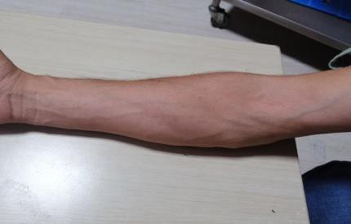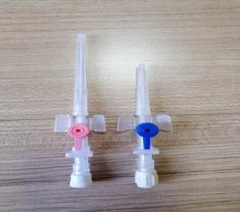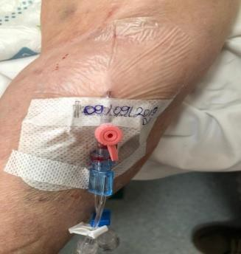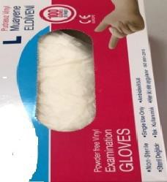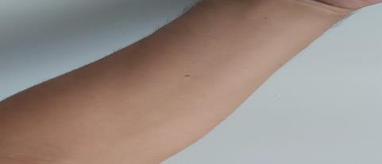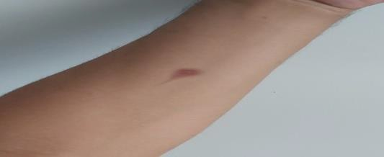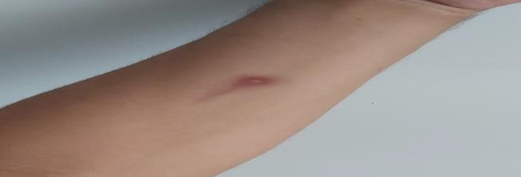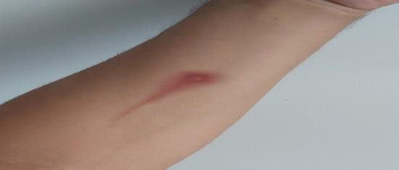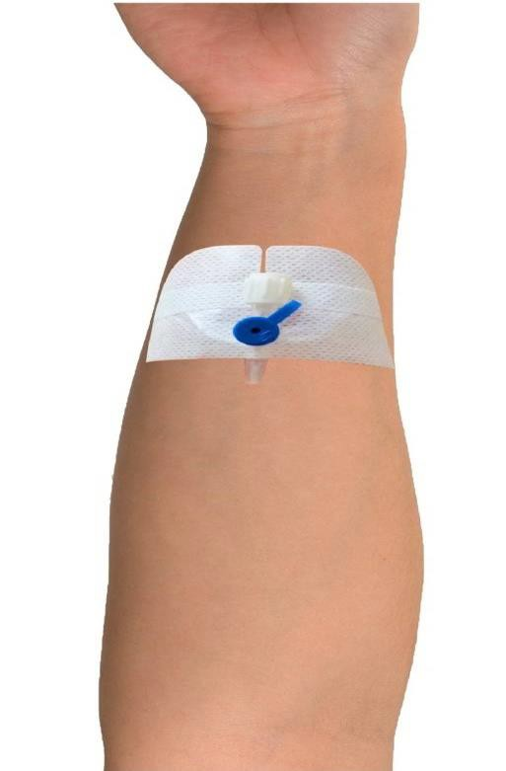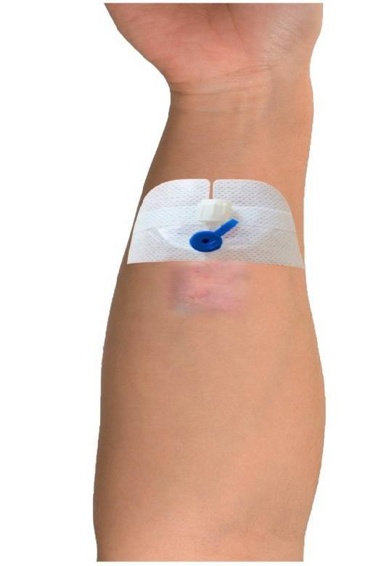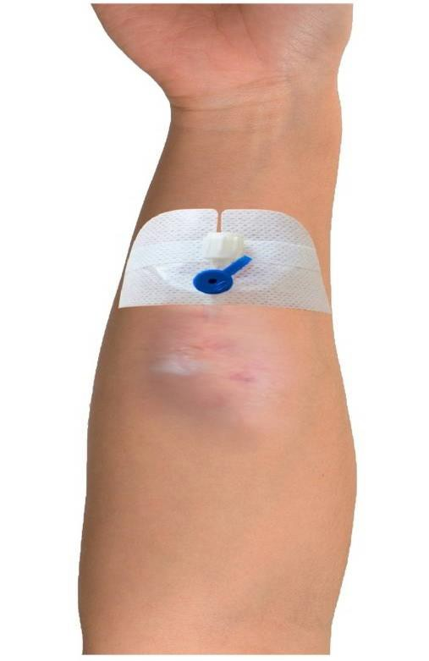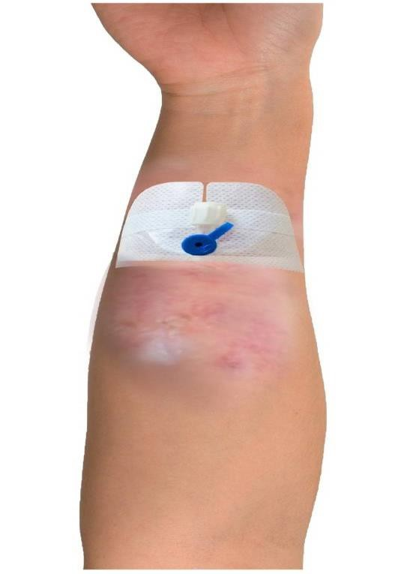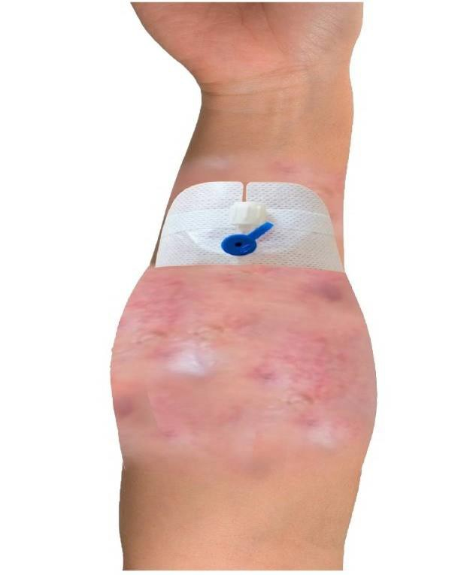

* Return to the

evaluation phase.

# Interventions

* Return to the

evaluation phase.

# Interventions

* Discontinue administration of the drug or fluid.
* Remove the catheter.
* If intravenous therapy is to be continued, insert a new catheter to the other extremity.
* Elevate the affected extremity.
* Apply a warm wet compress for 20 minutes 3 times a day.
* If necessary, apply analgesic and anti-inflammatory drugs according to the physician's orders for treatment.
* Evaluate the catheter site region once every 8 hours maximum.
* Record the date of removal of the catheter, the grade of complication developed, and the interventions performed.

# Interventions

* Return to the

evaluation phase.

# Interventions

* Discontinue administration of the drug or fluid.
* Disconnect the administration set from the catheter, aspirate the infiltrating drug or fluid with a injektor.
* Remove the catheter.
* If intravenous therapy is to be continued, insert a new catheter to the other extremity.
* Never apply pressure to the infiltration area.
* Mark the area with a pen for evaluation of the infiltration area.
* Elevate the affected extremity.
* Apply a dry cold compress if you intend to localize the non-vesicant drug or fluid in the tissue and reduce inflammation.
* Apply a dry warm compress if you intend to restore peripheral blood flow and distribute drug or fluid into the tissue.
* Evaluate the catheter site region once every 8 hours maximum.
* Record the date of removal of the catheter, the grade of complication developed, and the interventions performed.